Lab Activity: Advanced Firewall Routing and NAT
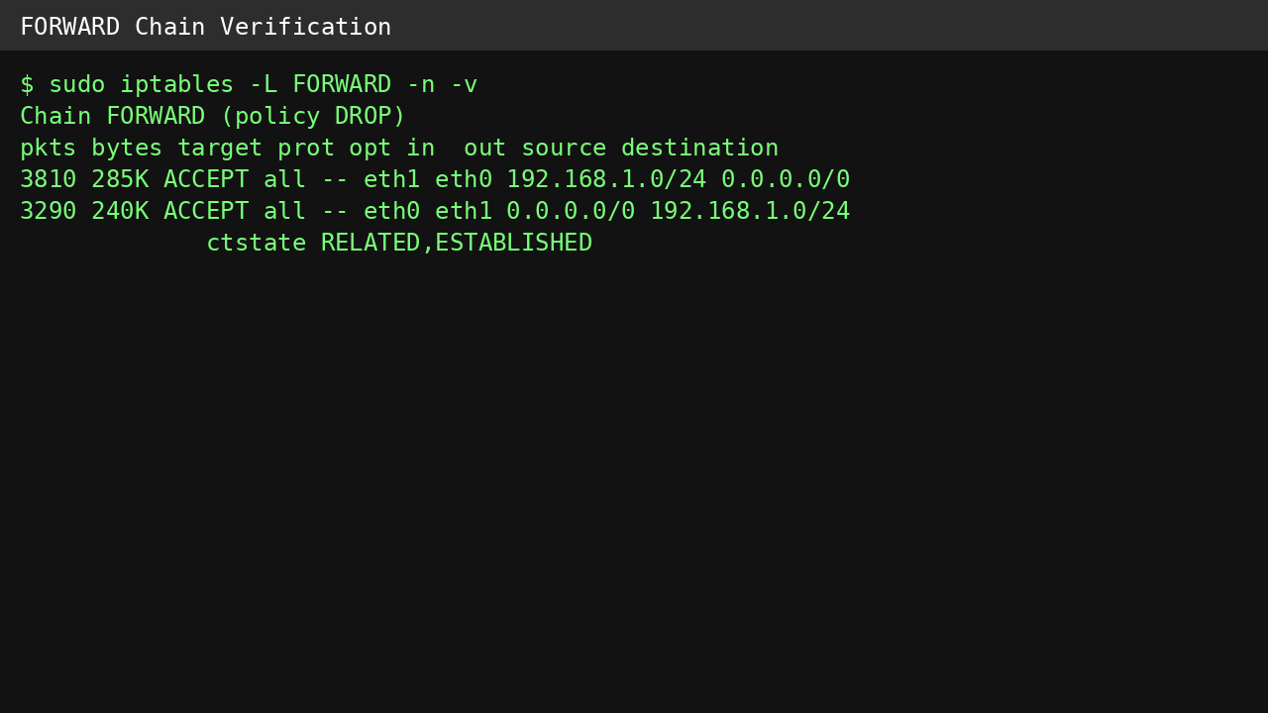
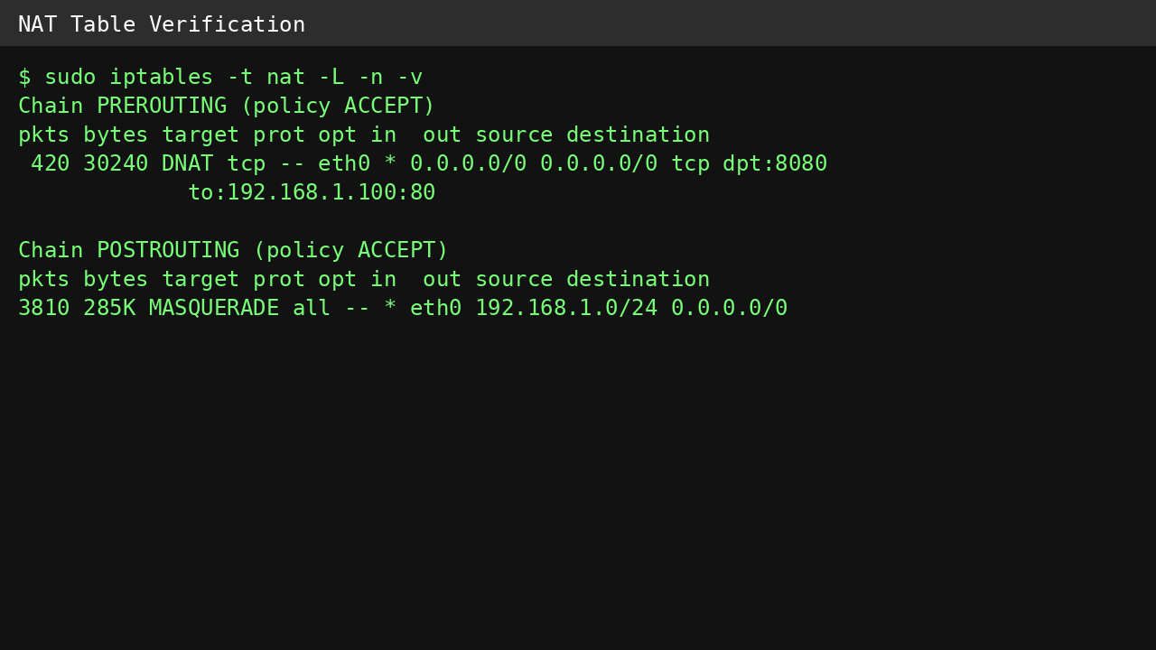

- Security Analysis
1. Obfuscation: How does MASQUERADE protect the confidentiality of the internal network's size and structure?
MASQUERADE hides the private IP addresses of devices inside the LAN by replacing them with the public IP address of the gateway. To external networks, all outgoing traffic appears to come from a single source. Because of this, attackers cannot easily determine how many devices exist inside the network or identify their actual IP addresses, providing an additional layer of privacy and security.

2. Port Remapping: What is the security advantage of using public port 8080 instead of internal port 80?
Using port 8080 on the public interface adds a small layer of security through obscurity. Automated attackers and bots commonly scan standard web ports such as 80 and 443. By exposing the service on a different port, the web server becomes less visible to basic automated scans. In addition, port remapping helps separate external access policies from internal service configurations, making network management more flexible.

3. The "Missing Link": If SNAT is configured but IP Forwarding is disabled, will internal clients have internet access?
No. Even though SNAT correctly translates private addresses into the gateway's public address, the Linux kernel will not forward packets between interfaces when IP forwarding is disabled. The gateway will receive the packets but will treat them as traffic intended only for itself and will not route them to the internet. Therefore, internal clients will not have internet connectivity until IP forwarding is enabled.

